**Tradescant**

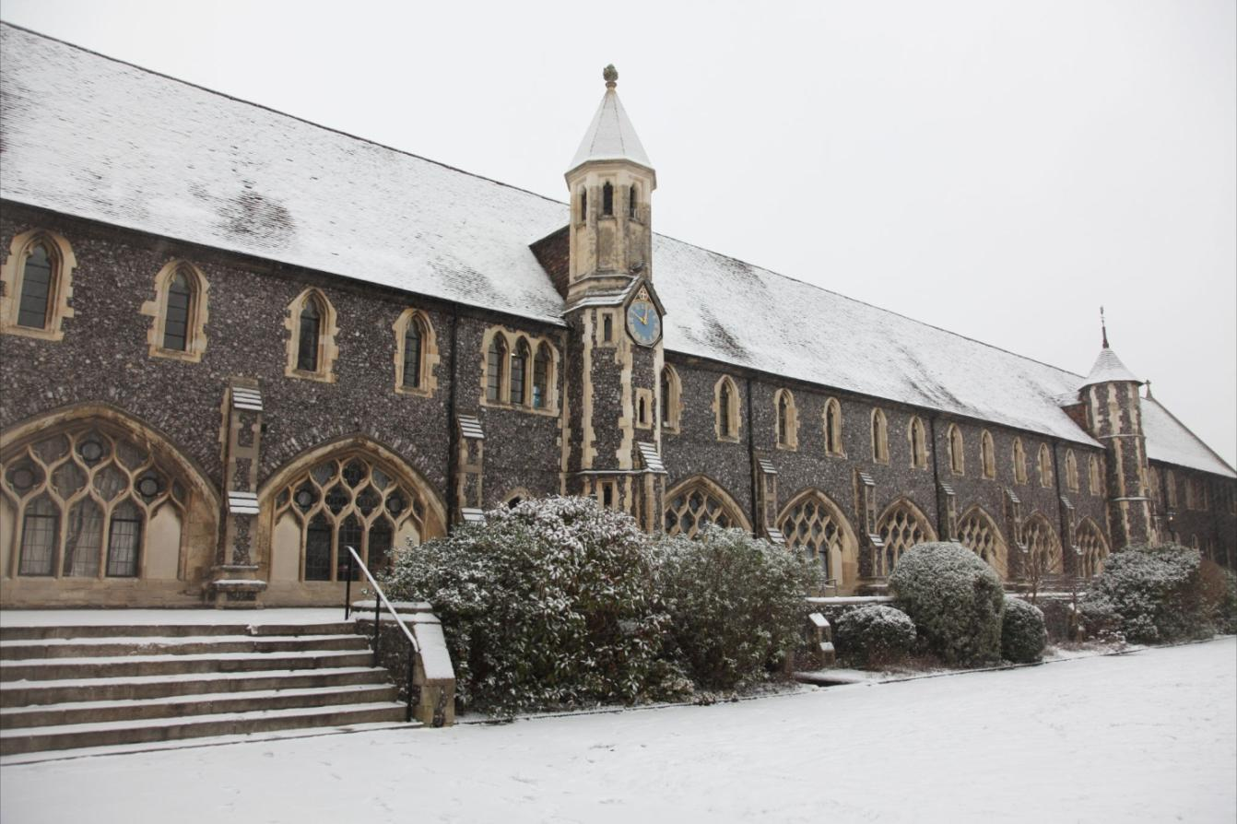

**House Handbook 2024-2025**

**Welcome**

May I wish you a warm welcome to Tradescant House! I very much hope that whether you are reading this as a new student, parent, guardian, family member or friend that you are excited about starting an affiliation with Tradescant that will hopefully stay with you for the rest of your life.

The house takes its name from the famous John Tradescant (KS 1619-23) who was a distinguished botanist and Royal Gardener to the King. It is for this reason that the rose is the house emblem, and the boys are all very proud of this.

We are a community that focuses on welcoming everyone and making sure that all the boys in the house are cared for and catered for. Everyone will have their own strengths and together as a family we will be able to thrive if all the boys commit to giving their best to one another.

It is true to say that the boys make the house. It is their pride, spirit and passion for the house that makes this place the fantastic boarding community that it is. I am extremely fortunate to have a wonderful Deputy Housemaster in Mr Pope, Matron in Miss Young and Tutor team to support the running of the house. I encourage you to get to know them as they will all have contact with your sons throughout their time here whether on duty or as their tutor.

l have an open-door policy in the house so that if any of the boys need anything they can come and grab me whenever. I, of course, encourage them in the evenings to seek out the duty tutor, however, if it cannot be sorted, I am more than happy to help to resolve any situation. It is key that they know that I am always available and wanting to help them.

I am passionate about maintaining the family friendly and positive atmosphere in Tradescant through House Events and Socials, I will be working hard to do this. The house should feel like a home away from home.

I look forward to meeting you and if you have any questions please do ask!

Mr Harrison

**Tradescant House 2022-2023**

Housemaster: Mr Rob Harrison Spanish and French

[rtmh@kings-school.co.uk](mailto:rtmh@kings-school.co.uk) Tel: 01227595591

Mob: 07789944515

Deputy Housemaster: Mr Jonathan Pope Economics [jhp@kings-school.co.uk](mailto:jhp@kings-school.co.uk)

Tutors: Mr Sam Barrett Head of Sports Excellence

[sib@kings-school.co.uk](mailto:sib@kings-school.co.uk)

Mr Matt Mcardle Photography

[mmca@kings-school.co.uk](mailto:mmca@kings-school.co.uk)

Mr Isaac Dilkes Senior Sport Graduate Assistant

[ivad@kings-school.co.uk](mailto:ivad@kings-school.co.uk)

Mr Finn Avison Teacher of English

[faa@kings-school.co.uk](mailto:faa@kings-school.co.uk)

Mrs Steph Dixon Deputy Senior School Nurse

[sms@kings-school.co.uk](mailto:sms@kings-school.co.uk)

Miss Madeline Young Matron/PCA

[my@kings-school.co.uk](mailto:my@kings-school.co.uk)

Matron: Miss Madeline Young

[my@kings-school.co.uk](mailto:my@kings-school.co.uk) Tel: 01227 595597

Mrs Silva Ariani Tel: 01227 595597

[sha@kings-school.co.uk](mailto:sha@kings-school.co.uk)

Health Centre: [health@kings-school.co.uk](mailto:health@kings-school.co.uk) Tel: 01227 595574

**New Starters Information**

**Mobile phones**  
Pupils are allowed to have a mobile phone, but they should never be used without permission in lessons or when walking around the school grounds (if they do so, they will be confiscated). Boys in the Shell, Remove and 5th year group will have their phones (and other tech) taken away at bedtime by the 6a monitors and then returned in the morning; all other boys are allowed to keep their phones overnight but are expected to use them responsibly.

**Tutors**

All boys are assigned a tutor who will meet with them at least once a week on Thursday at 11.10am (Tutor Period) when they can discuss academic and/or pastoral issues. In the first instance, academic questions or issues ought to be directed to them (email address are on the previous page).

Each tutor has one ‘duty night’ in the house each week and parents can arrange to contact them on the study telephone (01227 595591) on their particular evening between 7.30pm and 10.30pm.

**Exeats**

We ask that boys don’t take exeats for the first weekend (Shells – the first two weekends in the Autumn Term) or the last weekend of each term as this is protected school time (the weekends at the start of each term are particularly important for helping the boys to settle back into school routine), but after that they are allowed exeats if agreed with Mr Harrison. Exeat weekends start once a boy’s sporting commitments are finished on the Saturday afternoon and last until 9.30pm on a Sunday evening. In the first half of both the Autumn and the Lent Terms there will be **fixed** exeats for the whole school which run from Friday afternoon until Sunday at 9.30pm. All boys are expected to leave the house on Friday evening and ought not to return until 5pm on Sunday; overseas pupils must arrangements to stay with their guardians, if necessary. Specific fixed exeat dates will be available in the school calendar or on the school website.

**Sunday Leave**

Pupils may spend Sundays with their parents if prior notice is given, via email/telephone to Mr Harrison or using the official form on the school’s parent portal, so long as they do not miss any cathedral services (i.e. they may leave after Matins at approx. 9.30am or must return before Evensong at 7.30pm, depending on the calendared service). Pupils may have an unlimited number of Sunday Leaves, but they must manage their time and their workload accordingly. Sundays can also be an important time for house bonding, so it is not advisable to take leave every Sunday.

**Uniform**

You will have been issued an “Outfit for Boys Boarders” list, which will tell you all that your son needs regarding uniform and sports kit. As far as possible, all boys ought to have all items on this list. In winter, boys are permitted to wear a plain, dark winter coat (either dark navy, charcoal or black) and it must be large enough to be worn over – and not instead of – their school blazers. All non-uniform clothing, which the boys bring to school with them, must be named, either with a laundry marker or with a nametape. It is a good idea to order spare/extra nametapes from the school shop so that new items of clothing can be named as and when.

**Bedding**

All boys need to bring their own pillow/s and duvet with them to school (these ought to be named beforehand). They will also need **two** full sets of named bedding (pillowcases, sheet and duvet cover). It is best if this bedding is as colourful/unique as possible as white sheets and pillowcases are often mixed up or misplaced.

**Laundry**

In Tradescant, we are fortunate that laundry is done ‘in house’ every day. The boys are encouraged to take their dirty laundry daily to the laundry room and items will be washed punctually, often on the day. All clothing items must be named; I cannot stress the importance of this enough. All school uniform items can be left at the end of each term to be cleaned and ready for their return.

**School Bags**

As boys, particularly in the lower years, will have to move around the school to go to their various lessons we advise them to bring a suitable bag for carrying their books in. It does not have to be any particular colour or style, but it is important that it is clearly labelled and can be easily fastened.

**Pocket Money**

No pupil should ever have a large amount of cash with them in school. They may choose to lock a small amount away in their safe, but this is at her own discretion. The amount of money you give to your son for pocket money is entirely up to you, but we advise that £50 is sufficient per half term. Bankcards are recommended and the school can issue proof of address letters for those overseas boys wishing to set up UK bank accounts. Equally, as Housemaster I am happy to run a house bank if you would feel more secure with me looking after sums of money. This way I can sign money in and out.

**Electronic Equipment**

Boys are strongly encouraged to bring laptops, iPods, iPads etc. and, of course, many do, but they must be clearly named, and all smaller electronic goods must be stored in the boys’ safes for insurance purposes. If boys wish to listen to music in their dorms, they may do so, but must be aware that they are living with others. During prep time, boys may listen to music quietly (if in a single dorm) or through headphones (if in a dorm of more than one). Laptops or tablets which are being “misused” during prep (i.e. if a pupil is watching TV or on social media sites during prep) will be confiscated. Phones will be taken in during prep sessions as the boys should have ne need to use them. All pupils must sign an IT code of conduct form as part of their joining pack and the school Wi-Fi network has a number of safety filters to protect the pupils while they are using the internet. Cyberbullying of any kind is not tolerated and will be punished severely by the school.

**Tuck**

Boys may bring whatever they like as “tuck” and may purchase food from town whenever they are able to, but it must be stressed that attendance at school meals is compulsory for all (barring 6as who may eat breakfast in-house with permission) and snacks ought not to replace proper food. The Pupils’ Social Centre is open daily and enables students to buy tuck without leaving school. It is recommended that boys have their own lockable tuck box (can be purchased from the school shop). Boys may keep non-perishable food items in their dorms, but they must keep (named) perishables in the house fridges. The domestic staff will dispose of any out of date food. The House will have a regular supply of bread, milk, fruit and other treats throughout the week and on a daily basis at break times.

**Luggage**

International pupils and those pupils who are primarily based overseas may leave luggage in the boarding house during the Easter and summer end of term holidays (all pupils may leave their rooms tidy, but full during half terms and the Christmas holiday). Plastic storage boxes (from Wilkinson’s, IKEA or similar) are ideal for luggage being left behind as they are durable, easy to carry and can be stacked.

**Rules**

All boys are expected to abide by both the school and house rules. We recommend that pupils and parents read the school rules carefully before arrival and I enclose a copy of the house rules too.

**Daily Routine**

**Weekdays**

* Boys are encouraged to set their alarms for between 7.15 and 7.30am.
* Breakfast is served in the Dining Hall from 7.30-8.20am (doors close at 8.10) and all boys (bar 6as) go each day. A register is taken and if boys oversleep or miss breakfast, they can expect to have receive a misconduct, which will add up and end in a detention.
* Boys must leave the house for morning prayers by 8.25 at the latest. They ought to tidy their rooms and make their beds before leaving. Matron and I will check their uniform as they leave and will ensure that all boys have left the house.
* Morning prayers take place in the Shirley Hall at 8.35am every day (depending on the year group – there are House Assemblies on a Wednesday morning).
* Boys are in morning lessons from 9.00 am until 1.10 pm or 1.50 pm (depending on their lunch slots). They may return to the house for morning break between 10.10 and 10.35am and during their lunch break. Boys may also have visitors from other houses during these times, but the visitors must be signed in and any behaviour should be appropriate.
* Afternoon timetables vary – there may be lessons, games or activities – depending on the day of the week, but all start at 2.45 pm and are finished by 4.45 pm.
* Supper is then served from 6.00-7.10 pm and Boys may also have some free time. They may spend their free time in house, in other houses or in the Pupils’ Social Centre.
* Roll call or Tick Off is at 7.20pm each night in Tradescant and all boys must be there on time. On Monday, Wednesday and Friday this will also include a House Meeting where messages will be given.
* Prep begins at 7.30pm and goes on until 9.00 pm. All boys should be in their own dorms during prep and ought to be working throughout. Boys may also work in the school library with permission from the tutor on duty.
* After 9 pm, the boys may watch television, go outside on the Dovecote lawn (first half of Autumn Term and Summer Term only) or shower.
* Bedtimes are as follows:
  + Shells – 10 pm
  + Removes – 10.15 pm
  + Fifths – 10.30 pm
  + 6b & 6a – in own dorm by 11pm

**Weekends**

**Saturdays**

* Breakfast 7.30 – 8.20am
* No prayers
* Lessons start at 9.00 am and continue until 11.50pm
* In the afternoon the boys have sporting commitments followed by free time until supper.
* At 7.15 pm all boys must be back in house and there will be a roll call at 7.20 pm. Sixth Form boys may arrange a supper leave, but those in 6b must follow the official school protocol to do so. 6as must be in groups of 3 or more. Permission to be sought from Mr Harrison.
* There is no prep on a Saturday so the Boys may spend their free time however they choose. House events and inter-house socials will be organised for the boys.

**Sundays**

* If it is a ‘Matins weekend’, then the service starts at 9.30 am (roll call at 9.10) followed by brunch in the Dining Hall. If there is an Evensong service or no service at all, then the boys may lie in until brunch starts, usually at 11 am.
* Boys then have free time all day and can either use the time to catch up on work, to relax, go into town or visit the sports facilities at the Rec Centre.
* There is a roll call for everybody at 1.30pm and another for Shell, Remove and Fifth at 4.30pm.
* Supper is served from around 6 pm (the timing varies according to the cathedral service).
* Boys must again be back in house for 7.20 pm roll call. There is no official Prep Session on a Sunday but boys must respect those that wish to work and keep the noise levels to a minimum.

Tradescant House Rules

In a boarding house, we are one family and the boys are encouraged to remember that their actions have consequences. The following house rules are there to encourage happy and positive environment in house.

**Bedtimes** - Monday- Friday and Sunday

Shells 10 pm

Removes 10.15 p.m.

Fifth Form 10.30 p.m.

6b 10.45 p.m.

6a 11 p.m.

On Saturday, all 15 minutes later

## Building fabric and furniture

You are obliged to report any damage, breakages or spillages as soon as possible. Honesty is the best policy. Where genuine accidents occur, there is no problem. Where damage has been wilfully caused, students can be expected to pay for any work or furniture replacements needed.

**Bullying**

Please tell Mr Harrison, a tutor, Matron or a Peer Listener in house – whether seeing it or experiencing it. We have a zero-tolerance policy, and any bullying will be dealt with firmly.

## Cinema Leaves

These will be granted on a Sunday. Mr Harrison’s permission should be sought. You must sign out if a leave is granted.

## Computers, Computer Games and DVD's

Computer games and the downloading of music from the internet on personal computers and laptops can only be played during television viewing hours. Personal computers and laptops may only be used for academic purposes outside television viewing hours. The viewing of films on computers is only permitted during normal house TV viewing times. This applies to all days except Sunday.

## Electrical appliances

Please do not overload electrical sockets. Only automatic kettles are permitted. Toasters and sandwich makers etc. are not to be used in studies. Any phones and laptops will need adaptors for chargers – multiplugs are not permitted but extension leads are allowed. Any questions, please ask.

## Evenings and Preps

Prep will run from 7.30 to 9.00 p.m. on weekdays and Sunday. Prep ends when the bell sounds and not before. On Saturday and Sunday there is no official prep, however, those who wish to will of course be respected.

During prep:

* everyone must be quiet
* no movement between studies is permitted without the permission of the tutor on duty or the duty monitor
* any wishing to go to the School Library must make sure they are there by 7.40pm
* no outgoing telephone calls are to be made
* apart from overseas telephone calls from family members, incoming calls should be terminated politely and quickly with arrangements being made to return the call once prep has finished
* if you leave the House after 7.30 pm, you must obtain written permission from the duty tutor.
* if you are to miss the whole of prep for any reason, please ask Mr Harrison or Mr Pope.
* you must sign out if you are to be out of the house during prep

## Exeats

E-mailed permission must be obtained in advance by your parents or guardian. Such requests must be received by the Thursday before the exeat is to be taken.

Exeats will only be granted if all work is up to date.

Exeats can only be taken after all games / music / drama commitments have been fulfilled. (Please see School rules)

You must record your name in the signing-out book on departure.

You must report back in person to the duty tutor by 9.30 p.m.

#### House Duties

These must be completed before 7.45am

**Hymn books**These must be taken to School prayers and House prayers.

**Matron’s Surgery**All pupils may seek help from their matron at any time and, if the Tradescant matron on duty unavailable, there will be a published rota in house, which will tell the boys who the Matron on duty is in another house. Monday – Saturday there will be a Matron in house from 7.30am – 7.30pm. Outside of these hours the boys may seek help through a member of staff or by using the phone number published in house.

Boys may not go to bed during the day or miss lessons/games without a school matron’s permission. If you are too ill to attend lessons then you may not attend any other activities/commitments that day.

**Meals**

Attendance at all school meals is compulsory (bar 6as and breakfast).

**Medication**

It is forbidden for anyone under 16 to possess any medication without the authorisation of the Matron. Those who are allowed to self-medicate must notify the Matron or the Health Centre.

**Music**

No music played during prep should be audible outside the study or in another’s room. At other times, consideration must be given to others.

**Pizzas and take away food**

Allowed only once a weekend or in exceptional circumstances when granted by Mr Harrison or Mr Pope.

## Posters and Photographs

Care needs to be taken so that damage is not done to walls. All posters are to be in good taste. Mr Harrison’s decision will be final.

#### Privacy

You have a right to privacy. No pupil other than the duty monitor may enter a study without the occupant’s permission. Unless given permission to do so, you must not enter other boys’ dorms.

## Free Periods

You should be in either your studies or the library attending to your academic work in silence.

No music should be audible during lesson time.

**Signing Out**

Everyone must sign out if they know that they will be absent from prep or leave the house at any time after 7.30 pm.

You must also sign out if you are going on exeat.

You must also sign out if you will miss a roll call on a Sunday. Permission for missing a roll call must be sought from Mr Harrison or tutor on duty.

## Television Room

Please take care of this room. It is the social hub of the house. The PS5 and controllers will last longer if looked after.

Films of a 15 or 18 rating must only be shown with Mr Harrison’s permission.

The television and video may not be used during lessons and games times unless in exceptional circumstances (e.g post exam week).

### Terrace Windows

These are not to be used as doors to gain entrance to the House from the terrace or to the terrace from a study. No one is permitted to climb through windows other than in the event of a fire.

**Tutor Periods**

Attendance at tutor periods is compulsory. These should be treated as any other lesson.

## Visitors

Please treat all visitors to the House with respect. All adults visiting the House must be greeted with a smile and a ‘hello’ at the very least. Please stand up and turn down music if visiting parents enter your room.

No one is permitted to entertain visitors to the House before 8.30 a.m.

The school’s visiting policy must be adhered to.

**Correspondence**

Tradescant House

The Kings School

Monastery Street

St. Augustine’s Abbey

Canterbury

Kent

CT1 1PD

**A Map of School Bounds**

Everything *within* the red line is “in bounds”, which means pupils are allowed to walk there during their town leave (curfew times vary according to year group – see above). Anyone found *out* of bounds will be reported and punished – usually with a uniform gating of varying severity, depending on the nature of the incident.

